Academic Editing Chapter Launch Event
Summary report by Bailey Harrington

On 23 September 2022, the Editorial Freelancers Association and Editors Canada hosted a launch event for an academic editing chapter (EFA) and special interest group (Editors Canada). This is a pilot effort focused on bringing together editors who work on similar types of manuscripts, rather than those who are located in the same geographic area. This chapter addresses the need for an academic editing network. A total of 396 individuals registered to attend the launch event, and there were 336 distinct participants over the course of the event.

At the start of the meeting, attendees were reminded that:
- The event was not being recorded; and
- By participating in this event [they were] indicating that [they had] reviewed and agree[d] to abide by the EFA’s Anti-Harassment Policy and Editors Canada’s Workplace Harassment Policy.

Following a brief introduction introducing the purpose of the chapter and structure of the event, several polls were conducted; these were designed to provide aggregated information about the attendees and the academic editing work they do. The questions and their results were as follows:

Polls
Q1. What type(s) of academic editing do you mainly do? (multiple choice)

- Developmental/structural editing (94/208) 45%
- Line/stylistic editing (139/208) 67%
- Copyediting (180/208) 87%
- Proofreading (98/208) 47%
- Reference checking (67/209) 32%
- Indexing (15/208) 7%
- Other (23/208) 11%
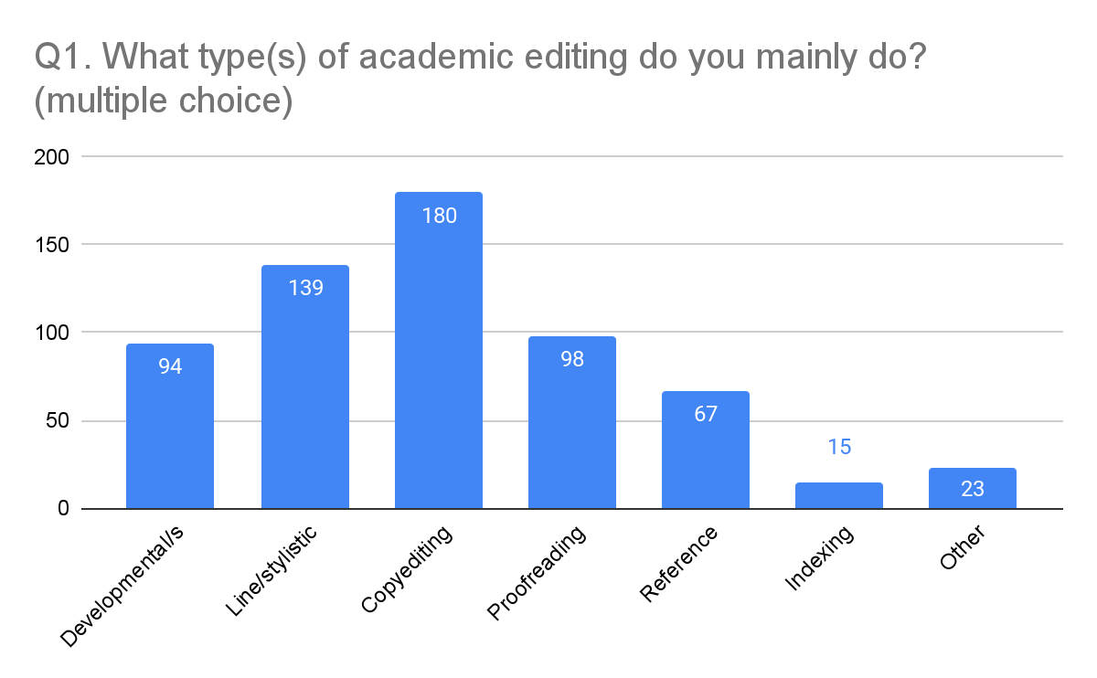

Q2. Who are your main clients? (multiple choice)

- Publishers/Presses (64/206) 31%
- Undergraduate Students (13/206) 6%
- Graduate Students & Postdocs (99/206) 48%
- Faculty & Staff (151/206) 73%
- Other (48/206) 23%
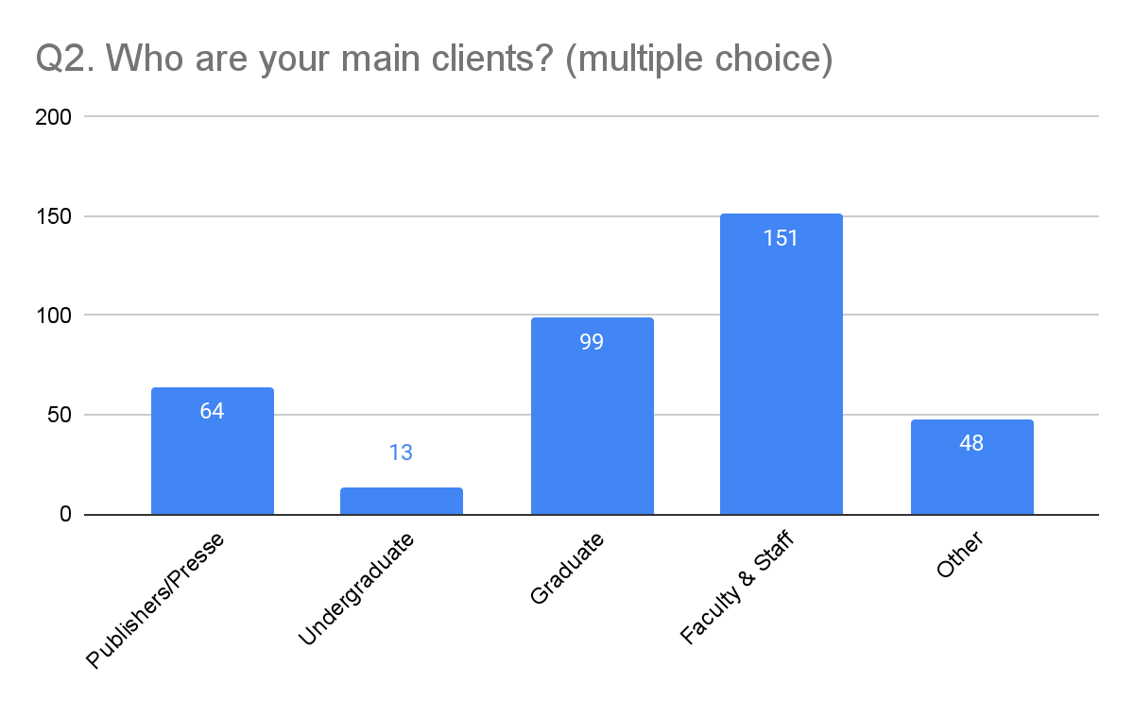

Q3. What percentage of your clients have English as a non-primary language? (single choice)

- None/few (50/203) 25%
- 25% (66/203) 33%
- 50% (35/203) 17%
- 75% (24/203) 12%
- All or nearly all (28/203) 14%
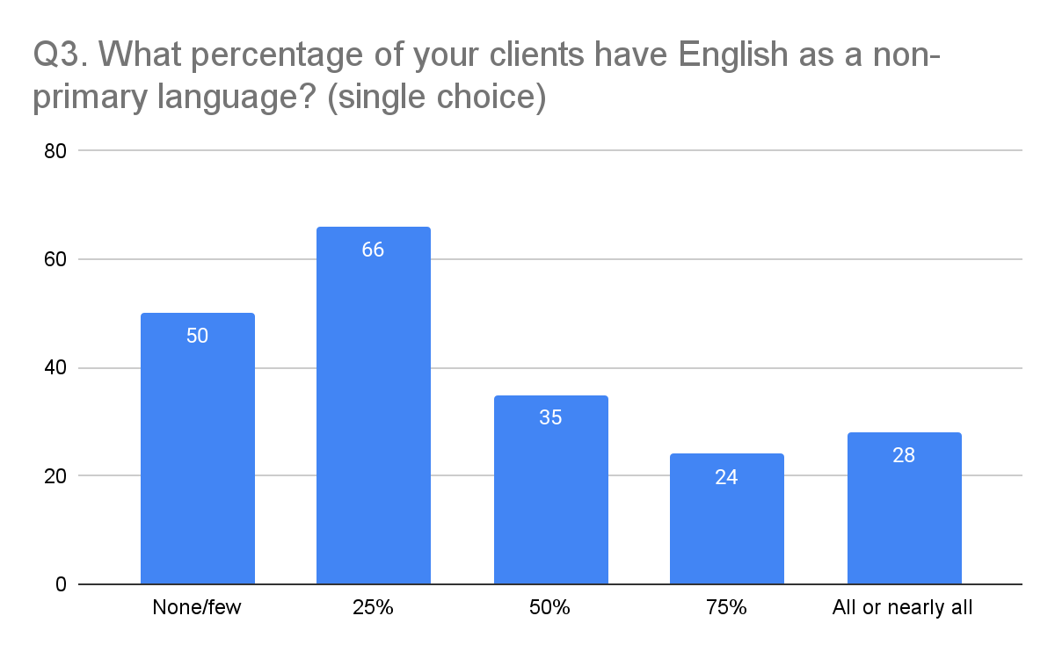

Q4. What type(s) of documents do you work on most? (multiple choice)

- Grant applications (32/209) 15%
- Journal articles (158/209) 76%
- Books (119/209) 57%
- Conference proceedings (7/209) 3%
- Dissertations (73/209) 35%
- Job/grad school materials and applications (31/209) 15%
- Other (46/209) 22%
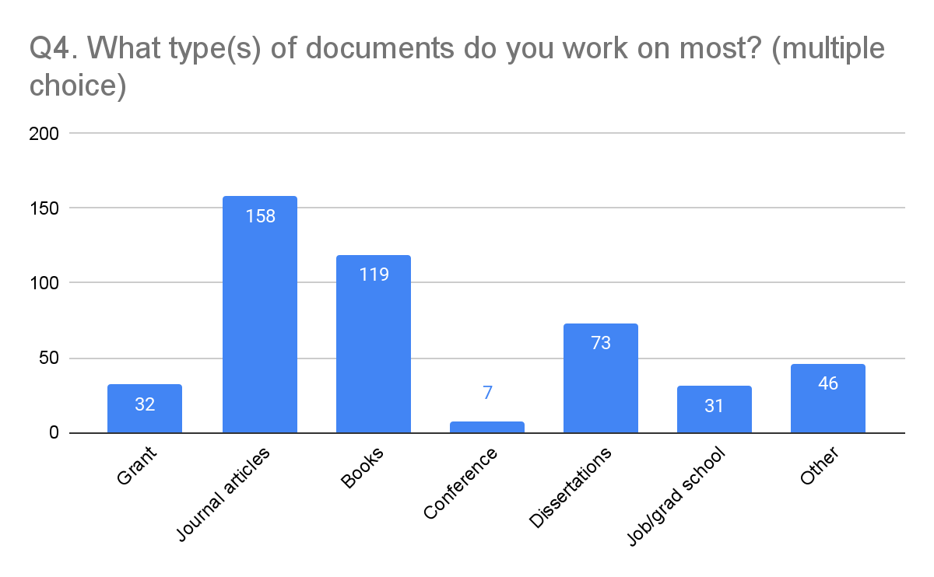

Q5. Which of these subject areas is closest to your main area of work? (multiple choice)

- Medical and health sciences (20/210) 10%
- STEM (27/210) 13%
- Humanities (82/210) 39%
- Social sciences (67/210) 32%
- Law (3/210) 1%
- Business (6/210) 3%
- Other (5/210) 2%
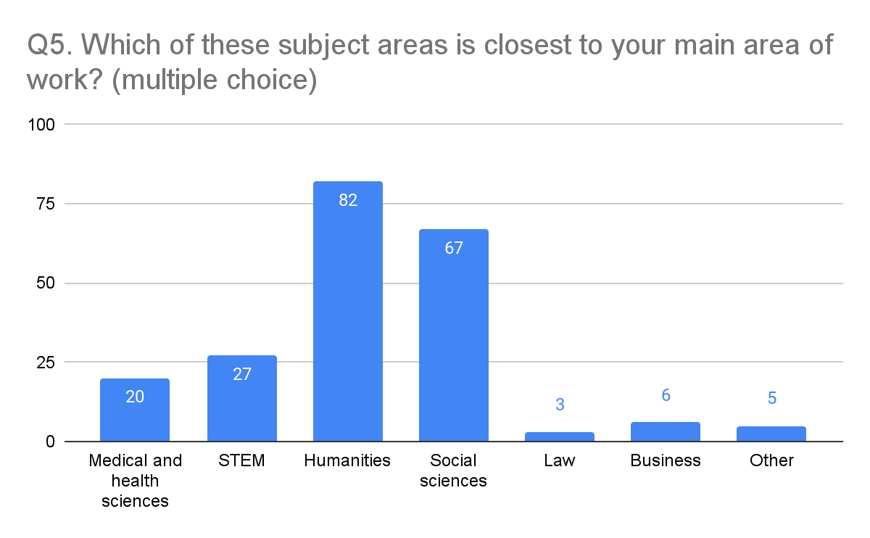

Panelists
The main event was a panel discussion between several academic editors, moderated by Cara Jordan.

- Cara Jordan (she/her) is the President and Chief Editor at Flatpage, an editorial agency and publishing house aimed at academics in the humanities and social sciences, nonfiction authors, artists, nonprofits, and businesses. Website: flatpage.com
- Karen Crosby (she/her) is Senior Editor and Managing Director at Editarians, a Calgary-based editing company specializing in academic writing, especially documents written in APA Style. Since 2002, we have helped hundreds of clients understand APA Style, reduce their overwhelm, and polish their papers to submit with confidence. Website: editarians.com
- Letitia Henville (she/her) is a book nerd, a bad swimmer, and the author of the monthly academic writing advice column “Ask Dr. Editor.” She specializes in editing for faculty members in the health sciences, education, social sciences, and humanities, with a special focus on grant applications and tenure and promotion dossiers. Website: shortishard.com & writingwellishard.com
- Antonn Park (she/her) has run her business, Blue Flower Editing, since 2017. She specializes in economics and crime, providing line editing and copyediting to a variety of clients, from individuals to publishers to institutions such as the World Bank and the Federal Reserve Bank of St. Louis. Website: blueflowerediting.com
- Amanda Pearson (she/her) is Deputy Editor of International Security. In this role, she manages the editing and production of articles accepted for publication to the journal. She collaborates with authors, making substantive comments and contributions to their articles. She also oversees the journal’s relationships with the typesetter and MIT Press.
- Akiko Yamagata (she/her) is an editor of scholarly manuscripts in the humanities and qualitative social sciences. As the owner of Graphite Editing, she helps academic presses, journals, and individual scholars to develop and polish manuscripts by providing developmental editing, line editing, and copyediting services. She also edits translations from modern and classical Japanese. Website: graphiteediting.com

Discussion Summary
The discussion began with panelists talking about their typical client and what their interactions tend to look like. Amanda mentioned that the first thing she does is poll the authors about their comfort level with being edited; she uses a scale from 1–10, with 1 being 'I strongly dislike people touching my text' and 10 being 'I really appreciate editing/suggestions/knowing the rules'. Akiko added that she will often meet with clients beforehand to discuss whether the scope of the editing should include comments on translations. Other panelists agreed that clients appreciate being asked about this up front. Some have had editing disasters in the past and this can help make them more comfortable.

Another topic that briefly arose from this was the topic of sample edits. The panel was split 50:50 between those who do sample edits and those who don't. Those who do offer them do so because it can help ensure everyone is on the same page and alleviate client concerns—including ones they didn't know they had.

The second topic was about professional development and experience. Several different methods of professional development and ways of gaining experience were discussed. Several panelists had completed a professional editing training programme. For those unable to afford the training programmes, or who want to continue their professional development after completing a certificate, other options such as editing book clubs, mentorship programmes, and mastermind groups were discussed.

The third discussion question was about clients with under-represented backgrounds. Several panelists have found ways to provide editorial help to people who can not afford their services such as charging lower rates, or creating resources that can help academics to self-edit effectively (writingwellishard.com). They also try to encourage editors-in-training who come from under-represented backgrounds by giving them extra time and encouragement, or actively hiring trainees from those backgrounds.

Antonn pointed out that no one had brought up race and mentioned that she helps Black and Brown editors by being visible—she appears on panels (like this one) and presents talks. Several websites were listed for groups who work with editors or authors from under-represented backgrounds, including editorsofcolor.com, indigenouseditorsassociation.com, and authoraid.info.

For the fourth discussion point, panelists were asked to give one tip for other academic editors, to help us better serve our clients. The primary focus of the answers was on engagement with clients—through positive feedback on manuscripts, outside of the editorial context on social media, or potential clients through content marketing. Additional themes included the importance of remembering authors' humanity and supporting them as individuals—not just clients; advocating for and championing clients during the editorial process; providing transparency about what academic editing entails as a way to showcase the value of our role; and helping authors understand where the ethical boundaries lie, as this is not always understood. Several panelists also noted that the client is not the only person who matters in the author–editor relationship. It is just as important to remember that you are also human and take into consideration what you need to do the job well.

The fifth topic was about how panelists got into working with academic or university presses (if they did). Many reported successfully cold-emailing presses. It was noted that: relevant expertise may be crucial; it is a good idea to spend time identifying presses and specific acquisitions editors produce books you would like to edit; Letitia introduced the concept of 'warm-emailing'—having previous clients introduce you to people who work with presses. LinkedIn Premium can be used to unearth some email addresses for direct contact, and the Association of University Presses publishes a list of contact emails; short-term subscriptions are relatively inexpensive: aupresses.org/membership/annual-directory.

Some of the panelists also talked about how working for academic or university presses can be used as a marketing tool—clients sometimes independently hire editors they have previously worked with at an academic or university press. Cara pointed out that working for individual clients is often more lucrative than working with the presses.

The next question arose out of answers to earlier discussion topics; panelists were asked to talk about mastermind groups—whether they had participated in one; how they found it; the purposes they serve. The answers emphasized the need for individual initiative for this to be a useful tool: organize it yourself; keep it small; know in advance what you want to get out of it. Mastermind groups can range from a discussion group mainly used to share information or provide accountability to something that feels more like a group of friends than one of colleagues. And, finally, the make-up of the group should relate to what everyone wants to get from it; it could be several individuals focused on editing professional development, or a group of freelancers in different fields all trying to grow their business. A relevant blog post can be found here: blog.editors.ca/?p=9544.

The last discussion question was about the best strategy for obtaining new academic editing clients. Fellow editors are a good source of recommendations, sharing of opportunities, et cetera. Another good suggestion was to go where your clients are; this can include actively engaging on social media, and also attending (physical or virtual) events like conferences. Antonn gave the example of attending a big economics conference to demonstrate interest in, and engagement with, the field—and posting about her attendance on social media. Karen pointed out that it is important to not 'jump into your clients' wallets (assume what they will or won't pay for editing); often, authors who understand the importance of having manuscripts professionally edited are willing and able to find a way to pay for it.

Q&A Session
The main event finished with the panel answering some questions from attendees before some breakout rooms were opened for attendees to mingle.

Question:
- A professor asked me how to reword his work for a lay audience; then I found he had used what I wrote in a published work—with no acknowledgement. How do people handle this situation, what is normal, et cetera?
Answer:
- Cara answered by saying that, at Flatpage, they have been in several situations that were kind of the opposite to this, where they did not want to be acknowledged in the final work, for a variety of reasons. The way they handle these questions is to put acknowledgement terms into the contract.

Question:
- I have moved from academia to editing, and am wondering how people will react; should I announce this?
Answers:
- Pia, the host, told them that writing to your colleagues is a great idea! You can do so in a way that is easy to forward (write an email that is sufficiently generic); tell them that they can forward it; and potentially reach more people that way.
- Cara added that it is possible to take clients secretly (for instance, if one is moonlighting as an editor), but that by embracing an editorial career it will become more sustainable, pay better, et cetera.

Another question was asked and discussed in the chat:

Question:
- I think of academic editing as editing academic student work (dissertations, etc) and scholarly editing as editing journals/books/etc. Is that just me?
Answers:
- Several people had never thought about a difference.
- Academic vs. scholarly is an interesting distinction that I haven't really thought about before. People don't tend to use the word "scholarly" in STEM fields, in my experience, and "academic" is used to cover all aspects of research & publishing done by academic labs, to distinguish it from private-sector research by biotech or pharmaceutical companies.

Resources

Where to look for mentorship programmes:
- Editors Canada: editors.ca/professional-development/john-eerkes-medrano-mentorship-program
- Northwest Editors Guild (open to folks outside that region!): edsguild.org/mentoring
- Relevant blog post: blog.editors.ca/?p=9932

Books that were recommended:
- Revise, by Pamela Haag
- Written/Unwritten: Diversity and the Hidden Truths of Tenure, by Patricial A. Matthew
- Writing Without Bullshit, by Josh Bernoff
- What Editors Do, by Peter Ginna
- Stylish Academic Writing, Helen Sword

Book clubs:
- Paths in Publishing group, pathsinpublishing.wordpress.com/who-we-are; book club sign-up: https://docs.google.com/forms/d/11GOH38bbifSsMikESJWGNsqkI5QDrpZnyoyOPGQpwFQ/viewform?edit_requested=true
- Letitia offered to organise a free editing book club for academic editors, or to make it a subgroup of the Academic Editing Chapter.

Supporting under-represented groups:
- Indigenous Editors Association (in Canada), indigenouseditorsassociation.com; a group for editors who are themselves Indigenous
- Academic Editing Circle, academic-editing-circle.us; primarily white editors providing pro bono editing (on their own schedule) to Black and/or Indigenous scholars
- AuthorAID, authoraid.info; volunteer academic support (including editing) for people from the Global South
- The Publishing Workshop, thepublishingworkshop.com; a resource for new editors from underrepresented backgrounds for entering world of publishing

Academic editing ethics:
- Ethical Editing of Student Texts: editors.ca/hire/guidelines-ethical-editing-student-texts
- A variety of resources at: publicationethics.org

Other resources:
- A Slack group for academic editors that Rudy Leon organised: scholarlyacad-cgc8026.slack.com
- A tutorial on hanging indents: erinkmaher.com/2022/05/27/one-weird-trick
- Check out native-land.ca to learn more about the indigenous people on whose land you live

Announcements:
- We're working on building up a mailing list to keep people informed going forward, but we also don't want to spam people. To stay up to date on events and next developments, keep your eye on the EFA page for the Academic Editing chapter: https://www.the-efa.org/chapters/academic-editing

Ideas? Suggestions? Want to volunteer?
- Contact the coordinators at: chap_academic@the-efa.org or academic.editing@editors.ca
- Check out the EFA chapter webpage at: the-efa.org/chapters/academic-editing
- Continue the conversation on social media #acwriEditing

